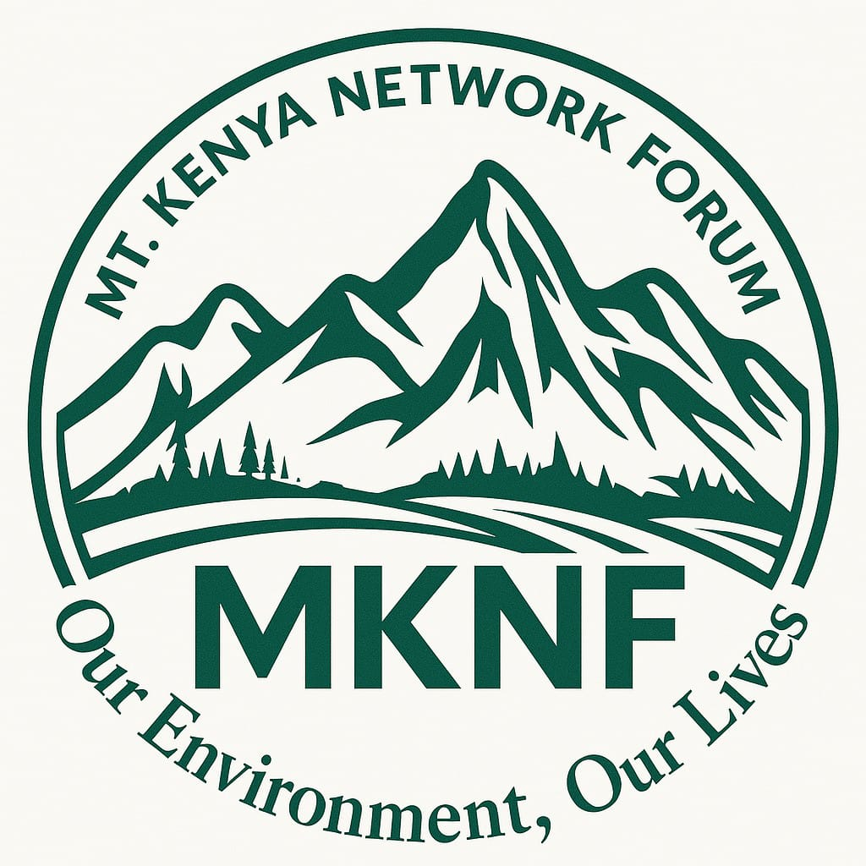

MT. KENYA NETWORK FORUM (MKNF)

MEAL PLAN (2026 - 2032)

Monitoring, Evaluation, Accountability & Learning Framework

INTRODUCTION
This MEAL Plan accompanies the Mt. Kenya Network Forum (MKNF) Strategic Plan 2026 - 2032. It provides a clear, donor-aligned, results-driven framework to monitor progress, strengthen accountability, and ensure adaptive learning across all programs and pillars.
This MEAL system adheres to global standards, including:
- OECD-DAC Evaluation Criteria
- IFRC & UN MEAL Guidelines
- Participatory and community-led accountability tools
- Results-Based Management (RBM)
- Data protection and safeguarding principles
The MEAL Plan positions MKNF as a transparent, evidence-driven organization capable of delivering measurable, scalable, and community-owned climate justice outcomes.
PURPOSE OF THE MEAL SYSTEM
The MEAL system aims to:
- Track implementation of the Strategic Plan 2026 - 2032 across four pillars.
- Measure outcomes and long-term impact of MKNF’s interventions.
- Strengthen accountability to communities, donors, partners, and government.
- Document lessons, innovations, and best practices for replication and scaling.
- Improve decision-making through continuous learning and real-time data.

THEORY OF CHANGE (TOC)
The MEAL system is built on MKNF’s organizational Theory of Change:
- IF communities are empowered with knowledge, legal tools, and platforms…
- AND climate policies and governance systems become more transparent and inclusive…
- AND resilience initiatives are community-driven and sustainable…
- THEN communities will achieve climate justice, protect ecosystems, and secure dignified livelihoods.
The MEAL framework operationalizes this logic through indicators, targets, and evaluation pathways.
MEAL OBJECTIVES
- Measure impact of grassroots empowerment, legal advocacy, and climate resilience initiatives.
- Generate accurate, timely data for reporting and strategic decisions.
- Enhance transparency and accountability to all stakeholders.
- Promote learning, innovation, and adaptation across all program areas.
- Document models and evidence that position MKNF as a global climate justice leader.

RESULT AREAS & KEY INDICATORS (2026 - 2032)

Impact Level Indicators
- Increased climate justice, environmental protection, and accountability in Mt. Kenya and ASAL counties.
- Improved household resilience for 5,000+ vulnerable households.
- Increased civic engagement and participation in climate governance (80% community satisfaction score).
- Strengthened ecosystems: 150,000 trees grown and monitored; improved water catchments.

Outcome-Level Indicators (Aligned with Strategic Pillars)

Pillar 1: Grassroots Empowerment & Civic Engagement
- of community members trained (target: 5,000; ≥60% women/youth)
- of functional community paralegal groups (target: 20)
- % increase in community participation in public decision-making
- Change in community knowledge (pre/post-test improvement ≥40%)

Pillar 2: Legal Empowerment & Governance Accountability
- of legal cases filed/supported through litigation fund (target: 5 major wins)
- of climate policies influenced or adopted (target: 4 counties)
- Annual publication of County Climate Governance Scorecards
- % increase in compliance with public participation laws

Pillar 3: Community Climate Resilience & Livelihoods
- of households benefiting from renewable energy solutions
- of youth/women-led green enterprises launched (target: 30)
- of trees grown (not just planted) and survival rate (%)
- of water catchments restored

Pillar 4: Organizational Sustainability & Influence
- Annual revenue diversification rate
- of strategic partnerships established
- Annual publication of State of Climate Justice Report
- Digital reach and engagement metrics (podcasts, dashboards, knowledge products)
MEAL TOOLS & DATA COLLECTION METHODS
MKNF will deploy modern, participatory, and digital data systems, including:

Quantitative Tools
- Digital data collection (ODK/KoBoToolbox)
- GIS mapping of trees, water sources & project sites
- Beneficiary registration & tracking system
- Renewable energy usage monitoring

Qualitative Tools
- Focus Group Discussions (FGDs)
- Key Informant Interviews
- Community storytelling sessions
- Social accountability forums
- Case studies and testimonial videos

Participatory Accountability Tools
- Community scorecards
- Public barazas & feedback forums
- SMS hotlines and helplines
DATA MANAGEMENT, QUALITY & SAFEGUARDING
MKNF will maintain strict data governance standards:
- Secure cloud-based storage
- Data anonymization for sensitive information
- Restricted access protocols
- Gender and age disaggregated reporting
- Safeguarding compliance for all MEAL activities
EVALUATION PLAN
MKNF will conduct:
- Baseline Study (Year 1) – establishes benchmarks
- Midline Evaluation (Year 3) – assesses performance, adjusts strategy
- Endline Evaluation (Year 7) – measures overall impact and sustainability
Where possible, mixed-method evaluations will be used.
External evaluators will be engaged for objectivity and independence.
LEARNING & ADAPTIVE MANAGEMENT
A structured learning system will include:
- Quarterly reflection and after-action reviews
- Annual Learning Reports
- Knowledge products (policy briefs, podcasts, infographics)
- Peer-learning exchanges across counties
- Documentation of best practices and innovations
MKNF will operate as a learning institution, not just implementing projects.
ACCOUNTABILITY TO COMMUNITIES & DONORS

Community Accountability
- Regular community feedback forums
- Transparent budget sharing
- Public dashboards with progress indicators
- Complaint response mechanism (CRM)

Donor Accountability
- Quarterly progress & financial reports
- Annual strategic reviews
- Audit reports and financial disclosures
- Transparent, data-driven communication

MEAL ROLES & RESPONSIBILITIES
- MEAL Manager: Leads MEAL system, analysis & reporting
- Data Officers: Field data collection & verification
- Project Officers: Pillar-specific monitoring
- Communications Officer: Visualization & dissemination
- Board MEAL Committee: Oversight & compliance
- Community Champions: Participatory monitoring

REPORTING SCHEDULE
REPORT TYPE | FREQUENCY | AUDIENCE
Monthly Activity Reports | Monthly | MKNF Leadership
Quarterly Progress Reports | Quarterly | Donors & Board
Financial Reports | Quarterly | Donors
Midline Evaluation | Year 3 | Donors & Partners
Endline Evaluation | Year 7 | All Stakeholders
State of Climate Justice Report | Annual | Public & Government
County Governance Scorecards | Annual | Public & CSOs

RISKS & MITIGATION MEASURES
- Political resistance: Strengthen coalition advocacy
- Data inconsistency: Staff training, digital tools
- Climate shocks: Flexible programming & adaptation funding
- Community fatigue: Rotational engagement, incentives

CONCLUSION
This MEAL Plan provides Mt. Kenya Network Forum with a strong, credible, and transparent system to measure impact, drive learning, and strengthen accountability.
It demonstrates that MKNF is:
- Results-driven
- Community-centred
- Evidence-based
- Scalable and sustainable
- A leader in climate justice and governance accountability
The MEAL Plan ensures that every project contributes to long-term systemic change for communities across the Mt. Kenya and ASAL region.

