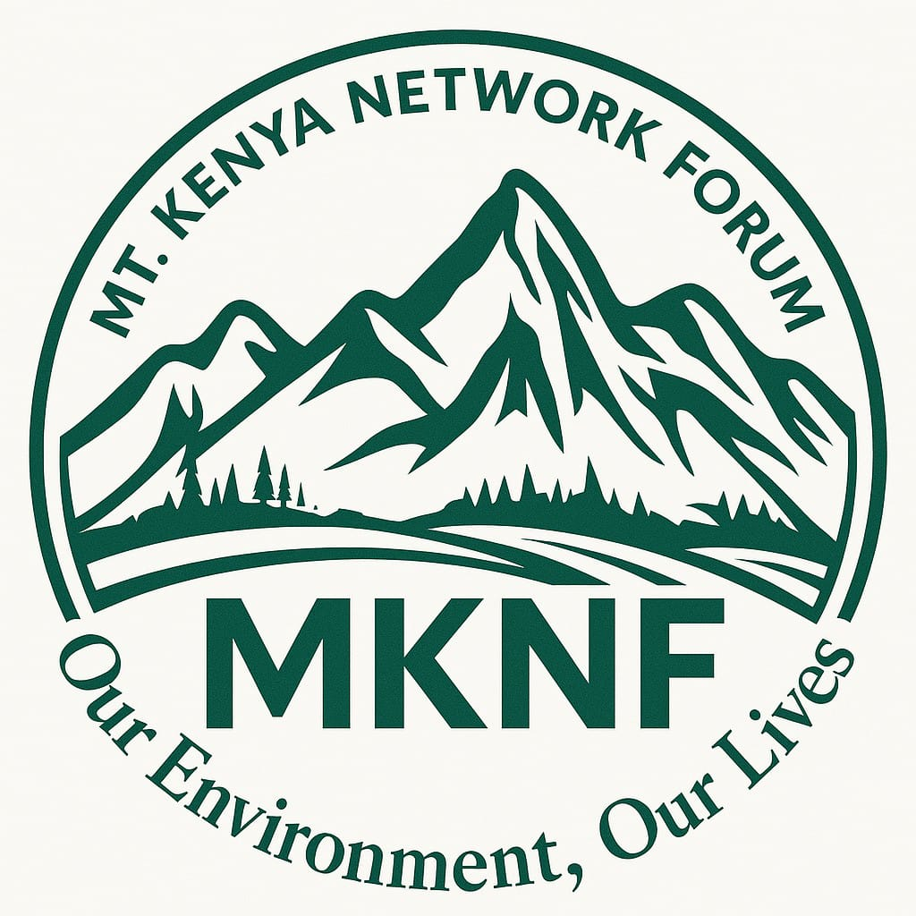

MT. KENYA NETWORK FORUM (MKNF)

STRATEGIC PLAN 2026–2032

ADVANCING CLIMATE JUSTICE, COMMUNITY POWER AND SYSTEMIC ENVIRONMENTAL ACCOUNTABILITY

EXECUTIVE SUMMARY
The Mt. Kenya Network Forum (MKNF) presents a bold, transformative, and donor aligned strategic plan for 2026–2032. Building on over a decade of grassroots mobilization, legal advocacy, environmental protection, and community empowerment, this plan positions MKNF as one of Africa’s most influential, community-rooted climate justice institutions.
This strategy is designed to:
- Scale proven models of community-led climate resilience
- Institutionalize legal accountability in environmental governance
- Strengthen grassroots civic power and democratic participation
- Expand impact-driven, climate justice innovations across Mt. Kenya and ASAL regions
- Build a sustainable, financially resilient organization capable of influencing national and global climate justice agendas
Centred on justice, equity, and local leadership, this plan integrates global best practices, modern MEAL systems, and transformative programming that attracts donors, partners, and multi-year funding investments.

VISION, MISSION & CORE VALUES

VISION
A climate-just, equitable, and resilient Mt. Kenya & ASAL regions where communities, especially the most marginalized—thrive, influence governance, and defend their environmental rights.

MISSION
To build the power of grassroots communities through legal empowerment, climate justice advocacy, and community-owned resilience solutions that advance environmental protection, social equity, and sustainable livelihoods.

CORE VALUES
- Climate Justice: Ensuring no community is left behind in the climate transition.
- Equity & Inclusion: Elevating women, youth, Indigenous Peoples, and persons with disabilities.
- Community Leadership: Local communities drive solutions and define their development.
- Accountability: Upholding integrity, transparency, and responsible governance.
- Courageous Advocacy: Speaking truth to power through legal, civic, and policy action.
- Sustainability: Building systems, ecosystems, and institutions that endure.

STRATEGIC POSITIONING
MKNF enters this strategic period with strong credibility:
- A landmark legal win (Petition E049/2023) strengthening climate governance participation
- Deep grassroots footprint across Mt. Kenya counties
- Proven success in renewable energy, tree restoration, civic mobilization, and climate education
- Strong leadership role in national and regional climate justice coalitions
- Established trust with communities, CSOs, and institutions
This plan elevates MKNF into a regional leader in community-driven climate and environmental justice.

THEORY OF CHANGE
If communities are equipped with knowledge, legal tools, climate solutions, and inclusive platforms; And if governments are held accountable and policies strengthened; And if climate resilience initiatives are community-owned and sustainable; Then marginalized communities will gain power, demand justice, protect ecosystems, and secure dignified, climate-resilient futures.

STRATEGIC PILLARS AND GOALS (2026–2032)
PILLAR 1: GRASSROOTS EMPOWERMENT, CIVIC EDUCATION & MOVEMENT BUILDING
Goal: Build a powerful, informed grassroots movement able to influence governance and defend environmental rights.

Objectives & Key Interventions
- Train 5,000 community members (60% women/youth) on climate governance, advocacy, and legal rights
- Establish 20 community environmental paralegal groups
- Create a Community Climate Justice Academy (flagship model)
- Develop and disseminate community toolkits, local-language guides, radio programs, and SMS campaigns
- Strengthen multi-stakeholder platforms for inclusive dialogue

Outcomes
- Increased civic capacity and participation
- Strong, coordinated grassroots network advancing climate justice
- Empowered communities capable of sustained advocacy

PILLAR 2: LEGAL EMPOWERMENT, POLICY INFLUENCE & GOVERNANCE ACCOUNTABILITY
Goal: Institutionalize transparent, inclusive, and rights-based climate governance at county and national levels.

Objectives & Key Interventions
- Achieve 5 landmark legal and policy outcomes strengthening environmental rights
- Establish an Environmental Justice Litigation Fund
- Produce annual County Climate Governance Scorecards
- Submit policy briefs, shadow reports, and legal analyses annually
- Advocate for adoption or strengthening of climate policies in at least 4 counties
- Monitor compliance with national climate laws, court rulings, and public participation standards

Outcomes
- Stronger policies and legal protections
- Improved governance transparency and accountability
- Increased community access to justice

PILLAR 3: COMMUNITY-OWNED CLIMATE RESILIENCE, ECOSYSTEM RESTORATION & LIVELIHOODS
Goal: Enhance resilience for 5,000 households through equitable, community-owned solutions.

Objectives & Key Interventions
- Expand renewable energy access (solar systems, cookstoves, water pumping)
- Scale agroforestry, beekeeping, and green enterprises for women and youth
- Establish a Community Resilience & Innovation Hub
- Grow and nurture 150,000 indigenous and fruit trees
- Implement community-led water conservation and catchment restoration
- Develop micro-enterprises supporting climate-smart livelihoods

Outcomes
- Improved natural ecosystems and watershed health
- Increased household resilience and income
- Community-driven adaptation to climate change

PILLAR 4: ORGANIZATIONAL SUSTAINABILITY, LEADERSHIP & RESOURCE MOBILIZATION
Goal: Build a financially secure, influential, and globally respected organization.

Objectives & Key Interventions
- Develop a 3-year rolling fundraising strategy
- Establish a Renewable Energy Social Enterprise to generate income
- Strengthen governance through Board development and internal policies
- Position MKNF as a thought leader via research, media engagement, and digital presence
- Produce annual State of Climate Justice in Mt. Kenya reports
- Create donor partnerships with bilateral, multilateral, and philanthropic institutions

Outcomes
- Diversified income streams
- Enhanced organizational resilience
- MKNF recognized internationally as a climate justice leader

CROSS-CUTTING PRIORITIES
- Gender & Social Inclusion (GESI)
- Digital innovation and geospatial monitoring
- Indigenous knowledge preservation
- Localization and community-led development
- Safeguarding and ethical governance

MEAL FRAMEWORK
MKNF will implement a world-class MEAL system integrating:
- Theory of Change
- Digital data collection tools
- GIS mapping of projects
- Community scorecards
- Baseline, midline, and endline evaluations
- Annual learning reviews and publications
- Real-time dashboards for tracking progress
A strong evidence base will drive donor confidence and impact visibility.

IMPACT TARGETS (2026–2032)
- 5,000 households benefiting from resilience initiatives
- 150,000 trees grown and monitored
- 20 paralegal groups established
- 80% community satisfaction score
- 10 major climate justice policy wins influenced
- 30 youth and women-led green enterprises launched
- 8 counties engaged through scorecards and policy advocacy

ALIGNMENT WITH GLOBAL & NATIONAL FRAMEWORKS
- Paris Agreement (Articles 6, 7, 9, Loss & Damage)
- SDGs 5, 7, 10, 11, 13, 16, 17
- African Union Climate Change Strategy
- Kenya Constitution 2010 (Articles 42, 69, 70)
- Kenya Climate Change Act (2016, amended 2023)
- FLLoCA and national climate finance mechanisms

CONCLUSION
This strategic plan positions MKNF to:
- Lead community driven climate justice in Kenya
- Influence policies and governance at national and county levels
- Deliver sustainable environmental and livelihood solutions
- Build an organization prepared for long-term success and global partnership
MKNF is ready to grow, innovate, and champion a just, green, and equitable future rooted in the power of the Mt. Kenya communities.

